91st Annual State Meeting
June 5, 2021
Hosted by Bluegrass Central Branch

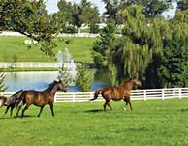
“Grounded in Strength and Resilience: A Path Forward”

Name: First |  | Last

Address:

City: |  | State: |  | Zip:

Telephone: |  | Branch:

E-Mail:

There is no registration fee for this Zoom convention.

Please Check All That Apply

Branch Member Branch Officer State Board Member Student Member
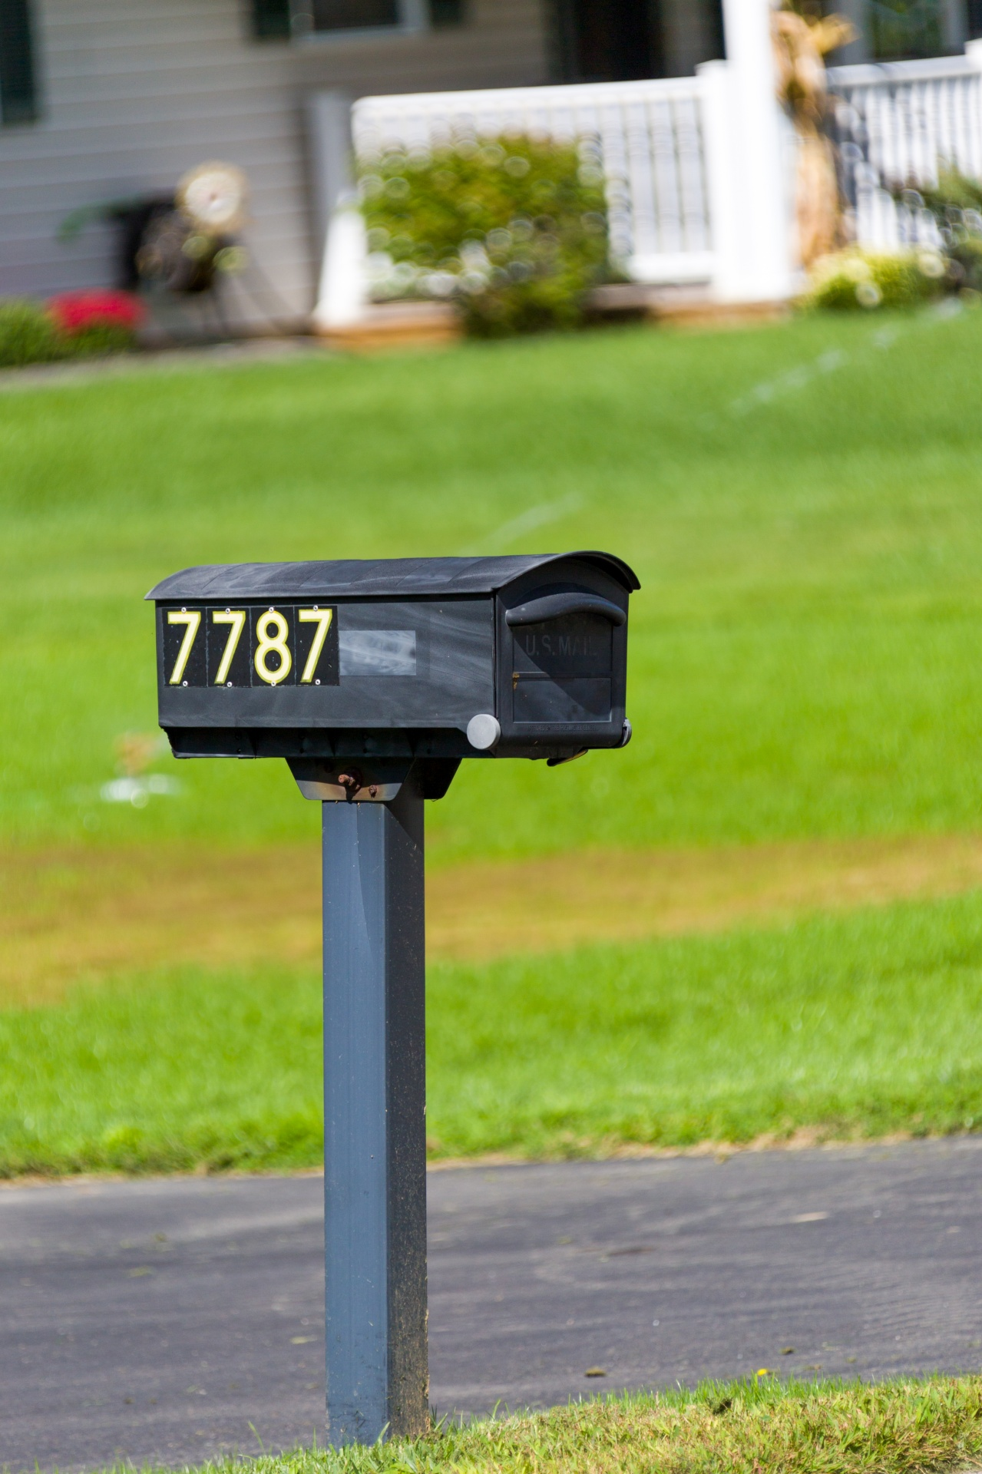
Member-at-Large
The first 30 who register will receive a gift bag in the mail.

Zoom link opens 9:00 am; convention begins 9:30 am and ends 12:45 pm. All times Eastern.

All AAUW members are welcome to attend the state board meeting. Do you plan to attend the State Board Meeting on Friday, June 4, at 4:00 p.m.? Yes No

If Yes, you will receive a Zoom email invitation with the link to the State Board meeting.
Mail or email this page no later than May 26, to:
Ruth Webb
1028 Pin Oak Dr
Frankfort, KY 40601
or
jsrhwebb@gmail.com

Be sure to watch for your Zoom invitation email with the link for the convention.

